# Objectives: Lab 03

The purpose of the first lab of BTP500 is to familiarize yourself with the Visual Studio User Interface and write a simple C++ program with functions, structures and classes. By the end of this lab, you should be able to:

* Successfully ran doubly linked list with all options using C++ functions.

# LAB 03 – SUBMISSION

Do not submit a .zip or RAR file.

# **2 files.**

# **1.   Word document BTP500-LAB3-NAME.DOCX filled with answers and screenshots**

# **2.   BTP500-LAB3-STUDENTNAME-doublylinkedlist.cpp**

Explore the linked list of data in C++.

* 1. Write a C++ doubly linked list to solve all the following functions mentioned below. Please use the attached header having a class template for any data type for doubly linked list. Submit the .cpp file in the submission link.
  2. Paste the screenshots here in the Word file for each of the functions above showing the initial data before the call of the function and screenshots to show the data after the call of the given functions. A minimum of 2 screenshots for each function and the total will be 16 screenshots for 8 functions.
     + "DList: push_front() starting with empty list",

* + - "DList: push_back() starting with empty list",

* + - "DList: push_front() 3 times then push_back() 3 times",A screenshot of a computer program

      Description automatically generated
    - "DList: push_back() 3 times then push_front() 3 times",A screenshot of a computer program

      Description automatically generated
    - "DList: pop_front() and pop_back() on empty list",A screen shot of a computer

      Description automatically generated
    - "DList: pop_front() on non-empty list",

* + - "DList: pop_back() on non-empty list",

* + - "DList: alternating pop_front()/pop_back() on non-empty list",

* + - "DList: calling push functions after pop functions."

* 1. Show an example of adding 2 nodes in pictorial representation at the front of a non-empty linked list. (if drawing nodes takes time digitally, please draw on a paper and attach as a picture here)

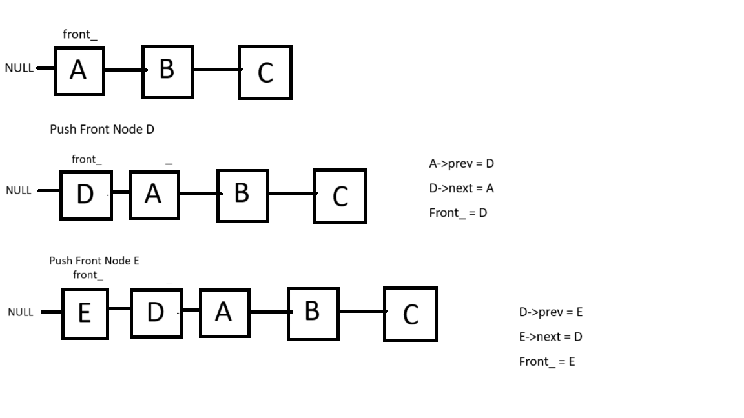

* 1. Show an example of removing 2 nodes in pictorial representation from the back of a non-empty linked list. (if drawing nodes takes time digitally, please draw on a paper and attach as a picture here)

